Note Two

* P(B | A)
  + P(B && A) / P(A)
* Random variables
  + X is a random variable if for every real number *a* there exists a probability P(X ≤ *a*), that is, this is the probability that the random variable X will take on a value that is less or equal than the number *a*
* Density Functions
  + f(a) is a formula or a table giving the probability that X takes on each possible value a
* **Expected value**
  + E(Y) = y1p1 + y2p2 + … + ykpk
  + Value that expect on average from the random variable
* **Variance and Standard Deviation**
  + var(Y) = E(r - µY)2 = ∑(r - µY)2 * p
  + How far is the value from the expected value
* Joint Distributions
  + Multiple random variables
  + f(x, y) = P(X = x, Y = y)
  + Marginal distributions
    - Probabilities that X and Y take on different values (**margin column or row in the table**)
  + Conditional distributions
    - Probabilities that one variable take on each value **given that the other has taken a given value →** P(X = a | Y = b) = P(X = a, Y = b) / P(Y = b)
  + **Independence**
    - X and Y are independent if
      * Conditional distributions are equal to the marginals for all possible values of Y
      * P(X = a | Y = b) = P(X = a, Y = b) / P(Y = b)
      * = P(X = a) * P(Y = b) / P(Y = b)
      * = P(X = a)
  + **Covariance**
    - cov(X, Y) = E[(X - uX)(Y - uY)]
    - cov(X, Y) > 0 → positive relation
    - If independent, cov = 0
    - cov(X, X) = E[(X - uX)2] = var(X)
  + **Correlation coefficient**
    - corr(X, Y) = $\frac{cov(X, Y)}{\sqrt{var(X)var(Y)}}=\frac{σ{}_{XY}}{σ{}_{X}σ{}_{Y}}=ρ{}_{XY}$
    - -1 ≤ corr(X, Y) ≤ 1
    - = 1 means perfect positive linear association
    - = -1 means perfect negative linear association
    - = 0 means no linear association
* Normal Distribution
  + u +/- 1.96 standard deviation = 95% of the data
  + Z score = (Y - u) / standard deviation
* Estimator and Estimates
  + Estimator
    - A function
  + Estimates
    - A value
* Estimation of the Mean
  + Y_bar = ∑(Y)/n
  + Y_bar is an unbiased estimator of uY.
  + var(Y_bar) = (standard deviation)2 / n
* Sample size matters
  + Convergence in probability, consistency, and the law of large numbers
* **Central Limit Theorem**
  + As n → infinity, the distribution of (Y-bar - µY) / (standard deviation) becomes the standard normal distribution ~ N(0, 1)
* Estimation of the Mean
* 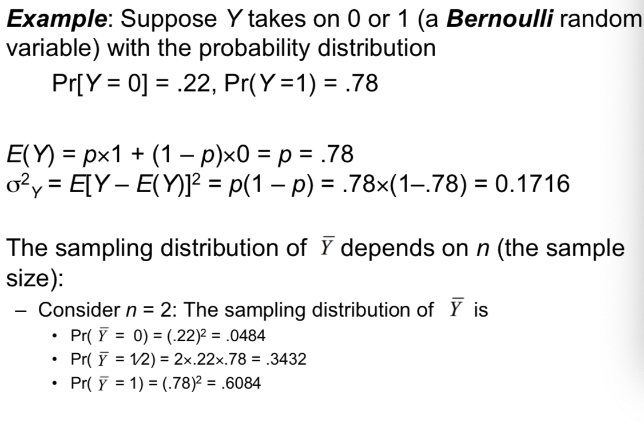
* Summary
  + The exact sampling distribution of Y-bar has mean uY and variance (delta)2/n
  + When n → infinity
    - 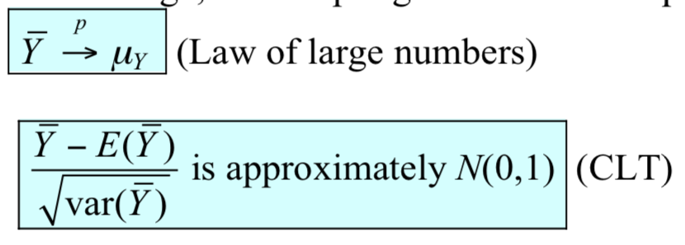
    - **Note: Y_bar does not equal to µY**